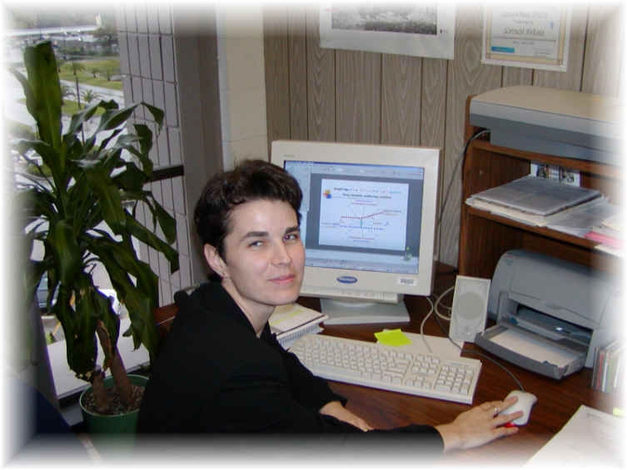
Curriculum Vitae

Liza Gyöngyi Baksay, Ph.D.

Tímár u. 14, 1st floor, apt. 4 4024 Debrecen, Hungary
Tel: +36 (31) 784-7811, Email: gyongyi.baksay@yahoo.com

Experience
- Experience with the educational systems of four countries (Hungary, Romania, Switzerland, USA)
- Project coordination and management: software integration in the CMS (Compact Muon Solenoid) project at CERN (European Center for High Energy Physics), Geneva, Switzerland
- Project management, technical consulting, software and innovation; consultant for multimedia conference systems at the Florida Institute of Technology, Melbourne, Florida, USA, and in Hungary
- Worked on numerous projects with complex software and hardware architectures, including data analysis, simulation, and detector operation (CMS-LHC) with data acquisition
- Student advising and teaching (universities and research centers in Hungary and the USA)
- Intensive group collaboration in international environments: Hungary, Romania, Switzerland, USA
- Proposal and report writing (institutional, group, and individual): US Department of Energy, US National Science Foundation, OTKA (Hungary)
- Participation in more than 700 publications; speaker at numerous international conferences, universities, and institutions

Educational Background
Year | Education
2006 | Continuing Education: Systems Engineering, Florida Institute of Technology, Melbourne, Florida, USA
2000–2005 | Ph.D. in Physics, Summa Cum Laude, Florida Institute of Technology, Melbourne, Florida, USA
1997–2000 | See employment section
1995–1997 | Master’s Program in Physics, Kossuth Lajos University, Debrecen, Hungary
1993–1995 | Physics Teacher Training Program, Eötvös Loránd University, Budapest, Hungary
1990–1993 | Mathematics and Physics Teacher Training Program, University of Oradea, Romania

Employment
Years | Position
2013–2026 | Private Tutor: mathematics, physics, English, Hungarian — Debrecen, Hungary
2013–2026 | Holistic healing with books, consciousness-based and energetic healing — Debrecen, Budapest, Hungary; Melbourne, Florida, USA
2007–2008 | Image Quality Systems Engineer, Medical Physics, General Electric Healthcare, Budapest, Hungary
2006–2007 | Research Scientist, Fermi National Lab (USA) and CERN, Geneva, Switzerland
2005–2006 | Multimedia Conference Systems Consultant/Project Coordinator, ORGALOGIC System Research Laboratories, Cologne, Germany / Delray, USA
1997–2000 | Research Scientist, Institute of Nuclear Research of the Hungarian Academy of Sciences (ATOMKI), Debrecen, Hungary

Appointments
Years | Appointment
2003–2007 | Visiting Research Scientist, Brookhaven National Laboratory, Upton, New York, USA
2001–2003 | Research Assistant, Florida Institute of Technology, Melbourne, Florida, USA
1997 | Exchange Research Scientist, University of Alabama, Tuscaloosa, USA
1995–2003 | Visiting Research Scientist, CERN, Geneva, Switzerland

Other Professional Activities / Memberships
- Member of the decision-making committee, American Physical Society, Forum on International Physics, USA
- Webmaster: FIP, APS, Experimental Physics Group, Florida Institute of Technology, USA Personal website: https://gyongyibaksay6.webnode.hu or write in google search: Baksay Liza Gyongyi webnode
- Memberships: Alabama Academy of Sciences, Florida Academy of Sciences, American-Hungarian Educators Association, Hungarian Academy of Sciences

Additional Skills
- Experience with complex high-level programming; user of CERN and Fermi Laboratory software libraries, Programming languages: Fortran, C++, Pascal
- Operating systems: Unix, Linux, Windows, MAC
- MS Word Office tools, LaTeX
- Web editors: Publisher, FrontPage, DreamWeaver
- Strengths: teamwork, independent thinking, efficiency, high creativity, goal-oriented approach

Achievements and Awards
Graduated with the highest distinction (Summa Cum Laude), Florida Institute of Technology Outstanding Physics Student of the Year, Florida Institute of Technology Best Presentation Award, Florida Academy of Sciences Link Foundation Fellowship, Florida Institute of Technology Sigma Pi Sigma Physics Honor Society Scholarship recipient, Transylvanian Museum Foundation, Hungary Scholarship recipient, Zsigmond Kemény Foundation, Hungary Student Fellowship, CERN Hungarian Research Foundation Scholarship

Languages
English (advanced), Hungarian (native), Romanian (advanced), German (beginner), Italian (beginner)

Publications
See more than 700 publications on the SPIRES-HEP website; search under G. Baksay and G. Marian

Personal
Baksay Liza Gyöngyi: Romanian, Hungarian, and American citizen Husband: Baksay László András (Professor of Physics, Department Chair, USA) Children: Baksay Réka Tünde (physician, Hungary) and Baksay Csanád Bátor (IT specialist, physicist, Hungary)

